**IFT 166 Introduction to Internet Networking**

**Lab 18**

**Spot the difference II**

**After you complete each step, put a ‘√’ or ‘x’ in the completed box   
&**

**Provide answers to the 4 open questions**

**Objective**

By comparing the configurations in two topologies, find the configuration errors in Topology B.

1. In packet tracer, open the file “Spot the difference II” (located in the modules sections below this lab).   
     
   You should see the following 2 topologies.

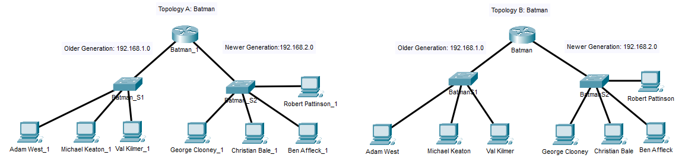



1. All the PCs can ping each other in Topology A.

All the PCs in Topology B should be able to ping each other as well. This is the not the case.  
  
There are 4 configuration differences in the 2 topologies (the 4 incorrect configurations are on Topology B)

**Spot the 4 differences.**

1. List each difference and why it needs to be corrected to allow the communications.



Fast Ethernet0/1 is configured to 192.168.3.1

Needs to configured to 192.168.2.1 to communicate to BatmanS2 (192.168.2.0)

Adam West is on the wrong default gateway.

PC was configured to have the same default gateway as its IP address. Default gateway should be configured to the router IP address.

Robert Pattison does not have default gateway setup. Also its entire IP configuration was incorrect (wrong IP to the network and set to DCHP)

Need to configure default gateway to allow communication to the router.

Christian Bale is on the wrong network – 192.168.3

To be on the same network is should be 192.168.2.X

Notes:

* Michael Keaton on Topography A was on the wrong default gateway (192.168.1.5)